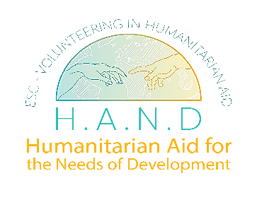
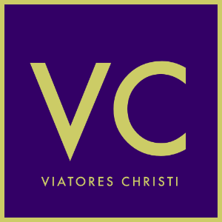
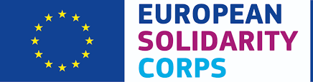

NEW European Solidarity Corps Humanitarian Aid Volunteer Role

Role Title: | European Solidarity Corps Humanitarian Aid Volunteer
Location: | Sarajevo, Bosnia and Herzegovina
Assignment Type | Volunteer Assignment
Project Dates: | Mid 2023
Duration | 2 months and 10 month assignments

About
Viatores Christi (VC) is a Dublin-based development organisation working within faith-based international development. VC works with over 30 partners across a range of sectors and countries. VC addresses needs through development and humanitarian assistance interventions and recruits, trains and places skilled personnel. In 2018, over 158,000 individuals directly benefited from the work of VC across partners in the areas of health, education, human rights, income generation and livelihoods. VC is a partner in a European Solidarity Corps Humanitarian Aid consortium project called Humanitarian Aid for the Needs of Development (HAND) with the following agencies:
- Egitim Programlari ve Evrensel ve Kulturel Aktiviteler Dernegi (EPEKA) - Turkey (lead partner)
- Orissa State Volunteers and Social Workers Association (OSVSWA) – India
- Bosnian Representative Association for Valuable Opportunities (BRAVO) - Bosnia and Herzegovina

HAND is now recruiting volunteers through the European Solidarity Corps Humanitarian Aid online portal for deployment with the Bosnian Representative Association for Valuable Opportunities (BRAVO) in Sarajevo, Bosnia and Herzegovina.

Bosnia and Herzegovina have had violent history, and especially the struggle for independence in BiH was especially cruel. The war 1992-1995 ended with the negotiated peace settlement known as the Dayton agreement. The agreement set the dividing lines among Serb Republic and the Federation of Bosnia and Herzegovina (plus Brčko District); the former controls 49% of the territory and the latter 51%.

After the war the state stepped on the thorny road of post-war reconstruction with the assistance from different international organizations, such as NATO, UN, EU and OSCE. This reconstruction is ongoing. Considering this situation, Bosnia and Herzegovina society is in the thrust for democratic changes.

Three decades after the war people in BiH are having difficulties with motivation and inclusion. Bosnia and Herzegovina are currently facing important challenges such as social engagement, unemployment and a migrant crisis. Also, young people tend to be passive and disinterested and BiH is facing brain drain where that is indicator considers the economic impact of human displacement (for economic or political reasons).

The assignments in Bosnia and Herzegovina are open to prospective volunteers from Ireland, under the age of 35.

The assignments are for either 2 months or 9 months in duration.

Volunteer Duties
The ESC volunteers will engage in some of the following supervised solidarity activities in Sarajevo, Bosnia and Herzegovina while also undertaking learning and development workshops for ESC volunteers.

- Social Media and video editing workshops
- Project Management education
- Workshops in kindergartens
- Workshops in centres for children with disabilities
- Volunteering in centres for the elderly
- Workshops with children in immigration centres

Expected benefits to the local community
- Sharing of relevant skills, knowledge and experience between community and volunteers, complementing each other in the process.
- Improved systems support for improved reporting and management in office settings.
- Opportunity to participate in solidarity activities in real development situations/perspectives when volunteers interact with communities allowing learning and sharing.
- Opportunities for skills and learning for volunteers.

Volunteer Specification
Ideally the ESC volunteers will have one of more of the following skills or qualifications:
- Marketing, PR/Communications degree or other equivalent qualification or experience.
- High degree of IT, Social Media and data literacy skills
- Experience of establishing and maintaining online communication platforms for sharing tools and information.
- Art / design skills or qualification
- Social care or social work qualification
- Experience and/or knowledge of international development, MEAL & WASH
- Teaching or facilitation skills with children, youth and adults
- Fluent English (verbal and written)
- Strong networking and influencing skills
- Experienced with photo and video-editing software

Essential Competencies
- A creative and strategic thinker
- Ability to work on own initiative, while also being part of team
- An ability to confidently represent the European Solidarity Corps, HAND and VC and effectively convey its key messages.
- Outgoing with an ability to interact with different, diverse groups of people

Reporting & Relationships Structures

The successful volunteers will be managed and deployed by the Bosnian Representative Association for Valuable Opportunities (BRAVO) in Sarajevo, Bosnia and Herzegovina and will report to the local ESC coordinator.

Working as part of the ESC HAND volunteer team in BiH, he or she will also support and collaborate with other volunteers and local staff.

How to apply

- Please apply directly to the European Solidarity Corps Humanitarian Aid team by registering on the ESC portal
- Once a candidate has registered on the portal and indicated his/her interest for the Humanitarian Aid Volunteering, the online training courses on EU Academy will be accessible via the “Online training” tab in their European Solidarity Corps account. They should select the option “Humanitarian aid training” (not General Online Training).
- Once redirected to the EU Academy platform, these will be the next steps:
  - Candidates will first be invited to make a self-assessment and will then be able to go through the online training and try to pass the test.
  - Those who pass the test can express their interest for the face-to-face training via a scheduling solution on EU Academy.
  - After having completed the face-to-face training, the candidates will become part of the pool of candidates eligible for being selected by Humanitarian Aid Volunteering projects on the European Youth Portal
- Volunteering in Humanitarian aid is open to all young people who:
  - registered for the European Solidarity Corps programme,
  - indicated in their European Solidarity Corps profile their interest to take part in Humanitarian aid volunteering,
  - are not older than 35 years old,
  - and reside in an EU Member State or a country associated to the programme (Iceland, Liechtenstein, Republic of North Macedonia, Türkiye).
- Once an assignment has been confirmed, volunteers may then avail of the following:
  - 3 month volunteer service agreement
  - Funding for flights, insurance, vaccinations.
  - Local accommodation and transport provided.
  - European Solidarity Corps Personal Development Plan leading to EU Youth Pass

